Name: _______________________

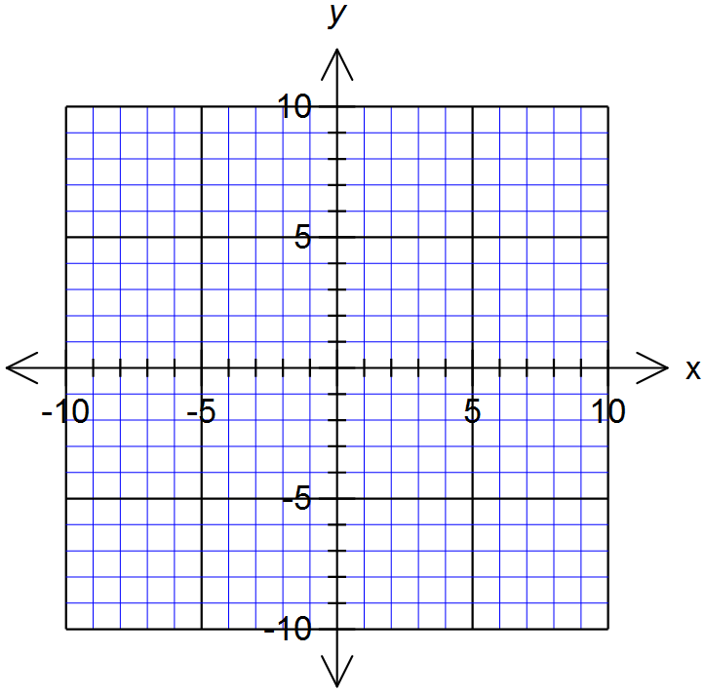
Linear relationships

- Fill in the table then plot it as a linear graph This is (1,5)

x | -1 | 0 | 1 | 2 | 3
y | -1 |  | 5 | 8

2. Fill in the table from the graph to the left

x | -2 | -1 | 0 | 1 | 2
y

3. Use the rule y = 2x + 1 to fill in the table below and then graph it

x | -1 | 0 | 1 | 2 | 3
y |  | 1

4. Now try y = x – 6 and plot on the same axes

x | -1 | 0 | 1 | 2 | 3
y

5. Try plotting y = 3x + 2 without a table
(Hint: use the gradient and y-intercept)

6. Complete the table (continue the pattern) and find an equation (rule) that turns x into y.

x | -4 | -3 | -2 | -1 | 0 | 1 | 2 | 3 | 4
y |  |  |  | -8 |  | -2 | 1 |  | 7

+ ____ + _____

Difference Pattern: _____________ When x = 0, y = _________

Rule : y = _____x +______

7. Complete the table (continue the pattern) and find an equation (rule) that turns x into y.

x | -4 | -3 | -2 | -1 | 0 | 1 | 2 | 3 | 4
y |  |  | -5 | 2 |  |  | 23

Difference Pattern: _____________ When x = 0, y = _________

Rule : y = _____________

8. Find the gradient and y-intercepts for these lines
A
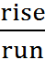
Hint: y-intercept: Where the line crosses the y-axis

- Gradient = ___________

Y-intercept = _________

Rule: y = ____x + _____

- Gradient = ___________

Y-intercept = _________

Rule: y =______________
B

- Gradient = ___________

Y-intercept = _________

Rule: _______________
C

- Plot a line that has a gradient of 2 and a y-intercept of -1

- Plot a line that has a gradient of - ½ and a y-intercept of 6

